Food Pantry Application

Introduction
The food pantry application is an effort to better serve the individuals and families that God has placed in our sphere of influence.

This document contains details and screen images that should provide users with the information needed to successfully use the application. Each screen will be covered in detail providing instructions for each feature of the application.

Main Screen

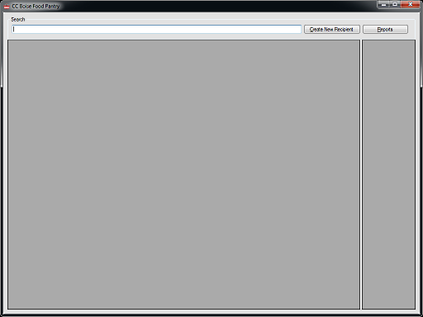

Main Screen Features
Search Text
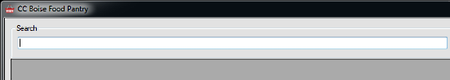
  - Enter the name or phone number of the Recipient you are searching for. Search text is not case sensitive and the results will be shown in the Search Results panel as you type.
  - Tip: You can view all Recipients by entering the space character in the search text box.

Search Results
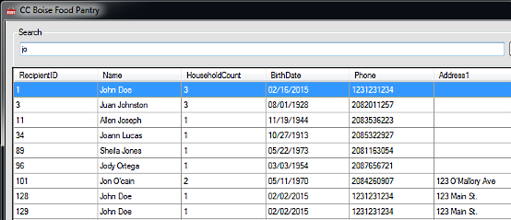

  - Search results are displayed as you enter text into the Search Text area.
  - Double-click on a search row to view/edit the Recipient information.
  - Right-click on a search result row to record a visit.

Recently Viewed
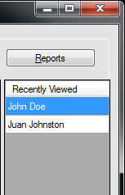

  - Whenever a Recipient screen is loaded, the record will be added to the Recently Viewed area for quick access.
  - Double-click on a name to view/edit the Recipient information.

“Create New Recipient” Button


  - Click this button to create a new Recipient.

“Reports” Button


  - Click this button to load the Reports screen

Recipient Screen
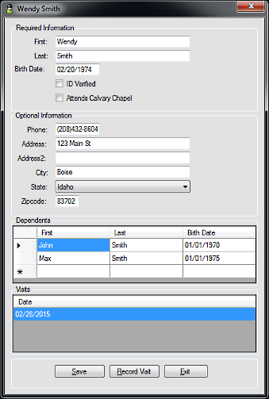

Recipient Screen Features
Required Information
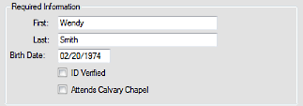
  - First: The first name of the Recipient
  - Last: The last name of the Recipient
  - Birth Date: The birth date of the Recipient in a MM/DD/YYYY format
  - ID Verified
  - Attends Calvary Chapel

Optional Information
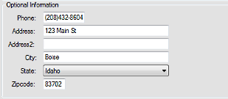
  - These fields are optional and can be populated if the information is available.
Dependents
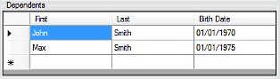
  - Dependents that live in the household to receive food.
  - Edit Dependent information by clicking the cell you want to edit. Birth Date should be in a MM/DD/YYYY format.
  - Add a new Dependent by clicking in the bottom row (*).
  - Delete a Dependent by click the space to the left of the row you wish to delete and press the “delete” key on the keyboard.
Visits
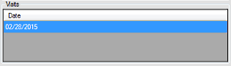

  - A record of the dates which the Recipient received food.

Controls
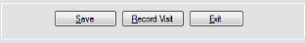
  - Save: Save edits to the screen
  - Record Visit: Record today's visit
  - Exit: Exit the screen and discard any edits

Reports Screen
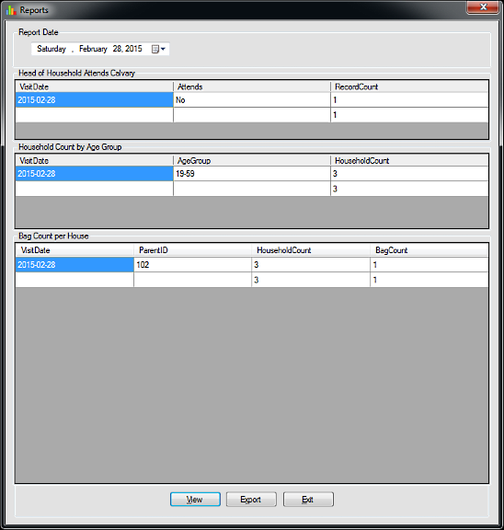

Reports Screen Features
Report Date
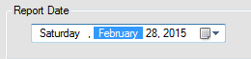

  - The date for which the reports are to be run.
Head of Household Attends Calvary
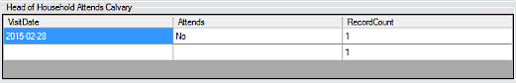
  - This report counts the number of Recipient visits on the given date and groups them by the “Attends Calvary” setting.

Household Count by Age Group
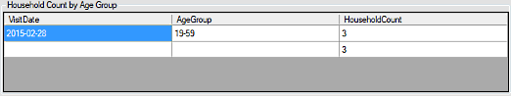
  - This report counts the number of household members (Recipient + Dependents) and groups them age.
Bag Count per Household
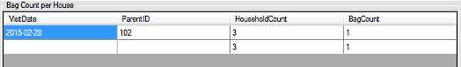
  - This report counts the number of bags given per household.
Controls

  - View: View the report results for the given date.
  - Export: Export the report results and create a copy of the database for external backup.
  - Exit: Exit the Reports screen.

Tips & Tricks
Search
- The search feature is not case-sensitive. Don't waste time using capitalization.
- You can search by partial text. E.g., 1234 would match a phone number of “(208)426-1234” or “(123)481-2343”. When searching for names just enter a portion of the first or last name. E.g., jo would match “Jo”; “Joe”; “John”; “Joanne”; etc.
- Enter a space in the search text box to see all Recipients in the system.
Buttons
- All of the buttons have “hot keys”. Notice the text on the button when you press the “Alt” key on the keyboard. “Save” will be displayed as “Save”. Pressing Alt+S is the same as pressing the button. This just saves from having to use the mouse to press buttons.
Forms
- You can tab between form fields and buttons by using the Tab key on the keyboard
- You can close the current form by pressing Alt+F4

